1. **Home Page –**
2. Banner Text X 3 and Images

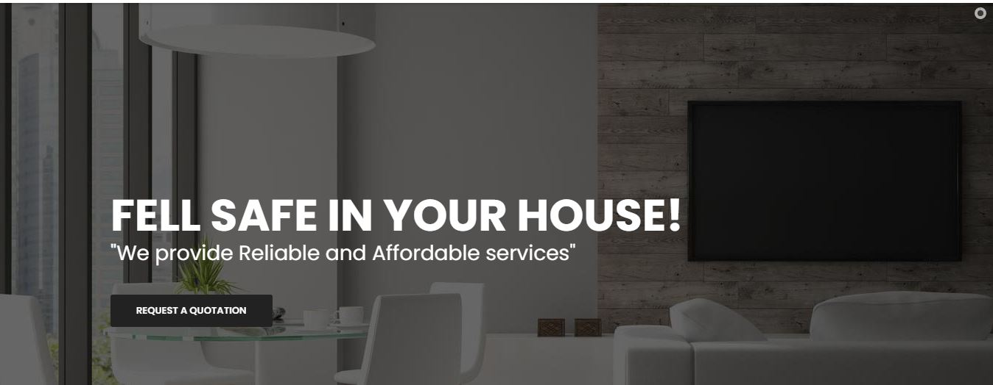

1. Services We Provide( Heading text & services description)

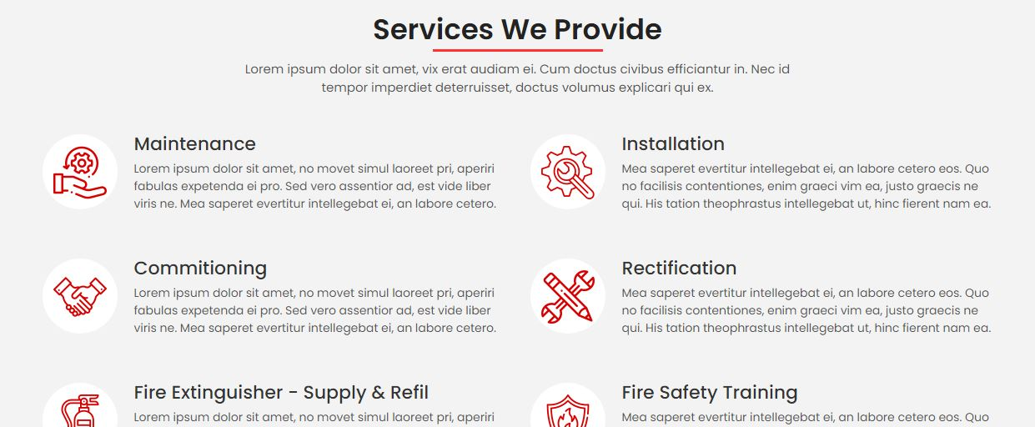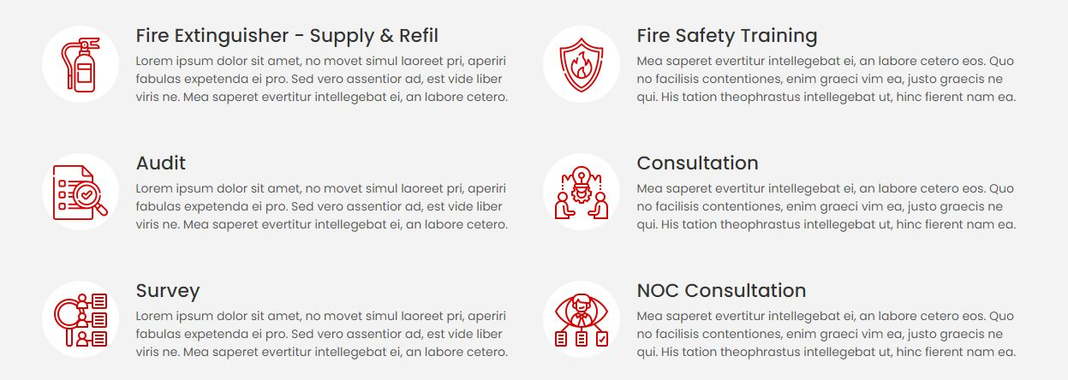

1. Why Us( Heading text & Description) And Image -

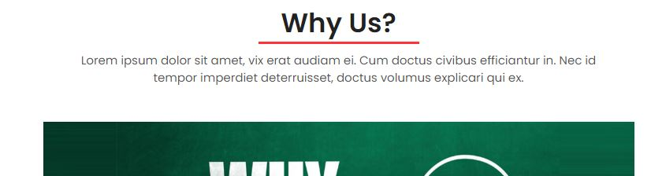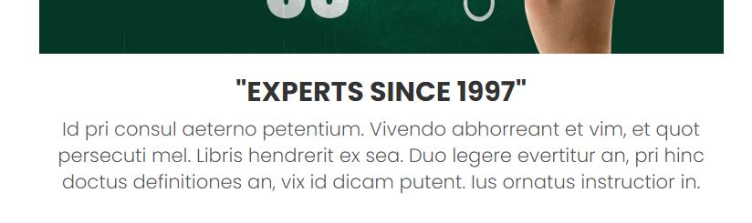

1. Our Projects(heading text)

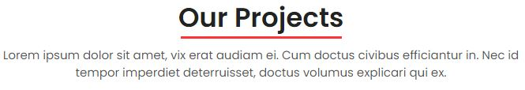

1. What Clients Say(Heading text)

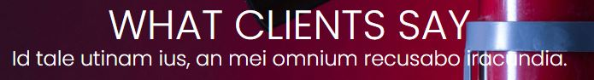

1. Footer Text –

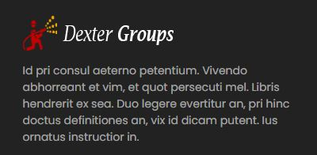

1. Terms and Condition(Modal) –

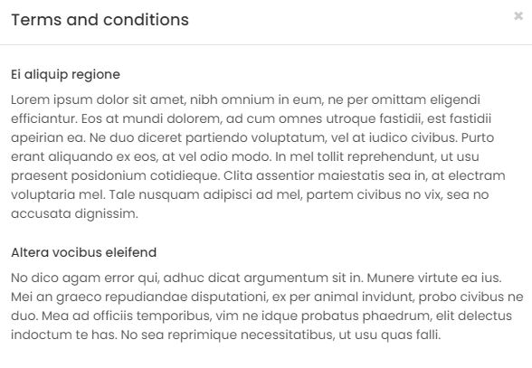

1. **About Us –**
2. About Banner Heading Text –

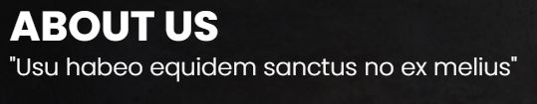

1. About Top Description And Image -

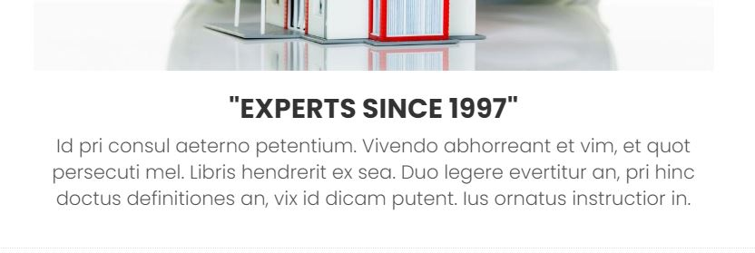

1. About Side Text –

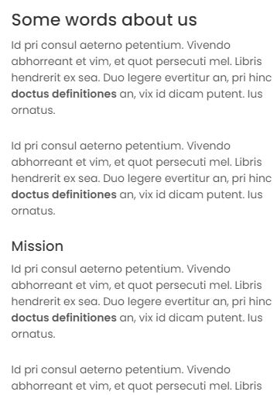

1. ISO certificates text –

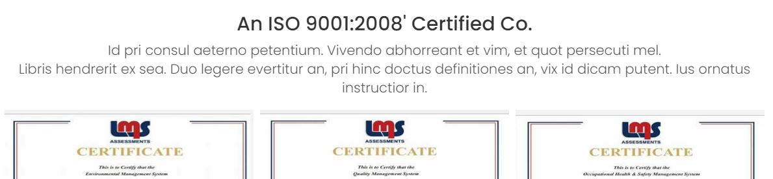

1. **Contact Us –** (heading text)

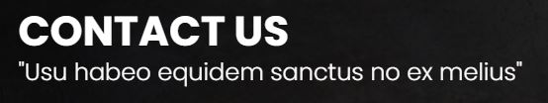

1. **Quotation –** (heading text)

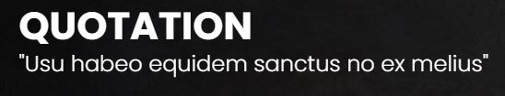

1. Side Div(Contact Us, Quotation, Products, Commercial Services, Technical Services)

